**URL: https://omnipresenti.com**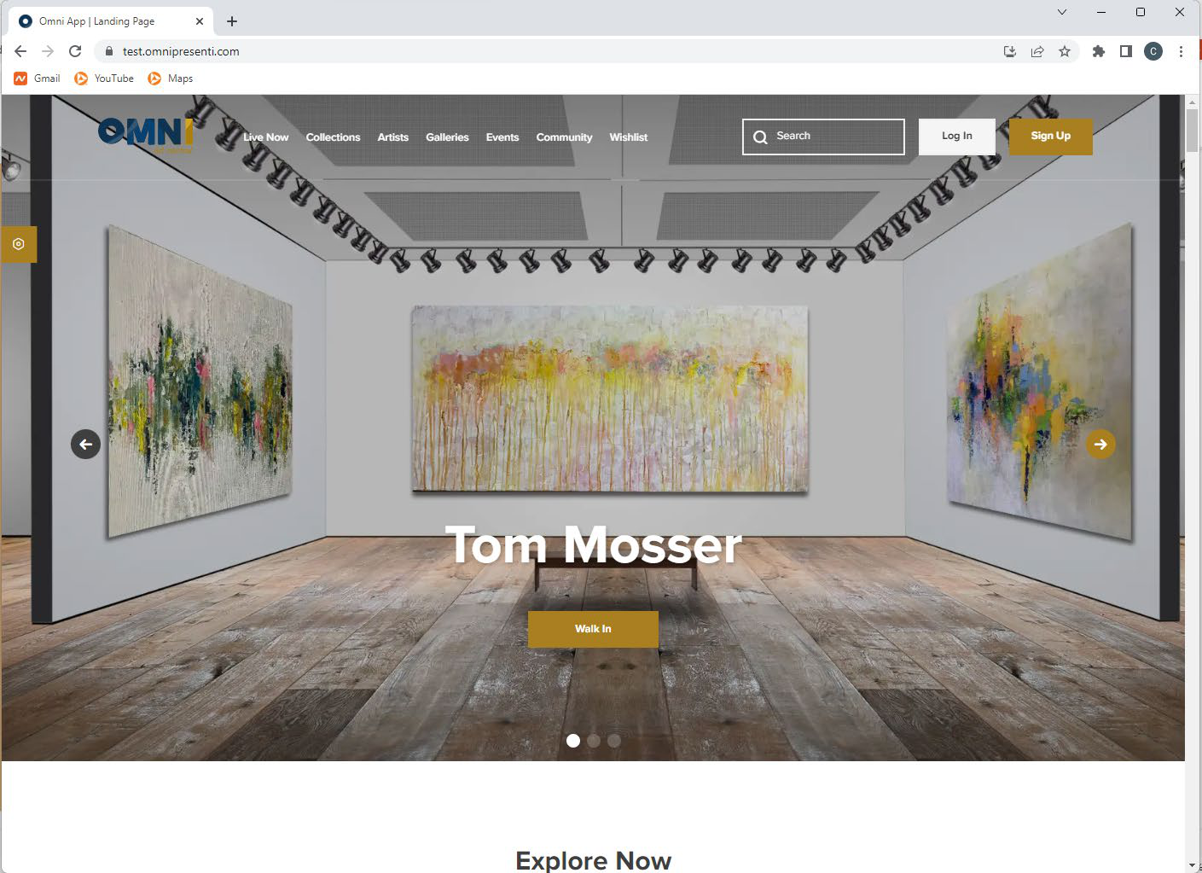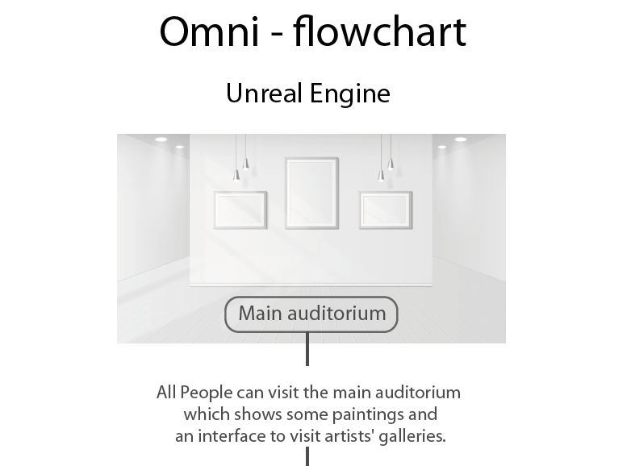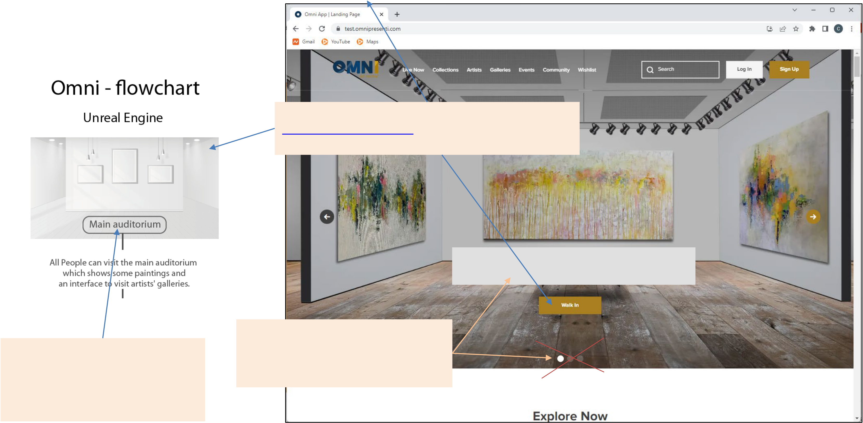

2. A user can enter the OMNIVERSE by either going to

[https://omnipresenti.com](https://omnipresenti.com/) and clicking WALKIN or by

|  |  |
| --- | --- |
| **URL: https://omniartcentral.com** | going to https://omniartcentral. |

**ART CENTRAL GALLERY**

1. Only show the ART CENTRAL

|  |  |
| --- | --- |
| 3. The Main Auditorium shows the ART CENTRAL GALLERY art. It will show the first work of art for each of | GALLERY prerecorded video in the  landing page (eliminate showing other  spaces prerecorded videos) |

the collections (about 20 works of

art).

1. Since we already have about 80   
artists and expect to increase it to   
many thousands of artists, a list is not   
practical. I suggest we give/integrate a   
search function and a filter function on   
the OMNI database, which we already   
have in OMNI.